Set 7 - Assignments on TSQL

All the questions from this set are based on the default emp and dept tables. The screenshots of expected outputs are of some other database editor. So, in SSMS the output’s format, look & feel will differ.
For the first 10 questions you are free to use any SQL technique such as Inbuilt SQL functions, Group By, Having, Aggregate Functions, Joins, Sub Queries, Set Operators, Derived Tables, Window Functions, looping, cursors, stored procedure, user defined functions, etc.

- Create the following type of Deptno-wise Sub Total report.

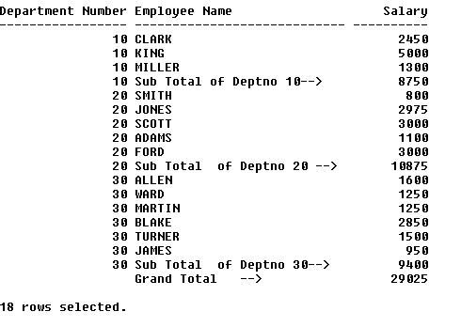

2) Create the following type of Department-Job Sub Total report –

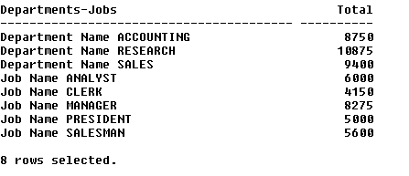

3) Create the following sub-totals of year-wise salary details.

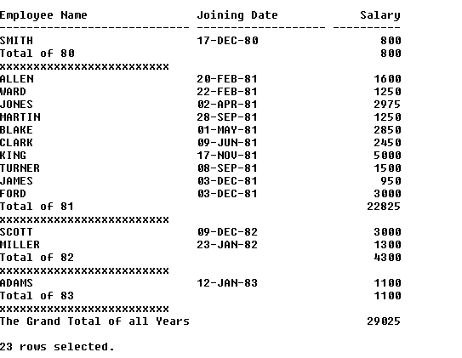

4) Display the deptno-wise employees with the record of the lowest earner in each deptno as shown below.

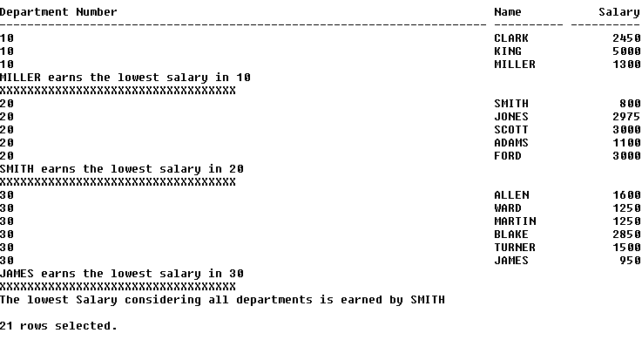

5) Display the highest two salary records within each job as shown below --

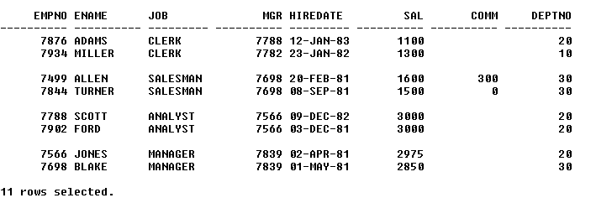

6) Display the records sorted as per deptno along –with the record of the oldest employee within that deptno as shown below --

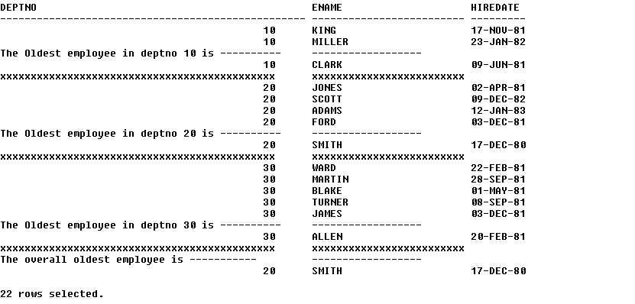

7) Display the employees earning less than the average salary of their own jobs as shown below --

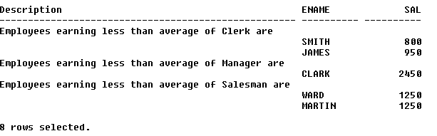

8) Create the following Master-Detail type of report

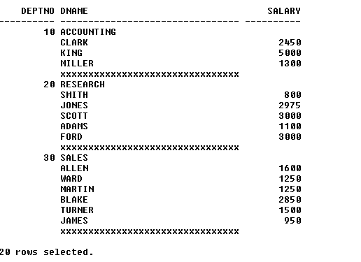

9) Create the following Master-Detail Summary type of report.

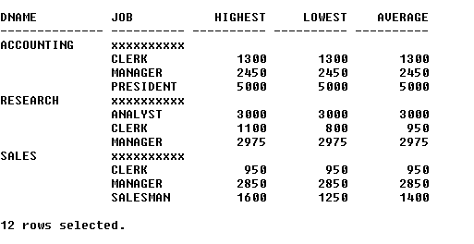

10) Create the Organization hierarchy report as shown below –

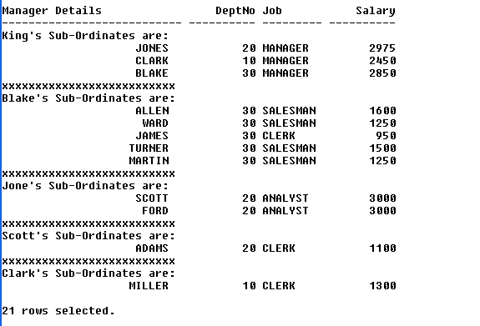

Question 11, 12 and 13 should be solved only using the technique of Correlated Sub Queries.

11) Display the highest two salary values from emp table.

12) Display the fourth lowest salary value from emp table.

13) Display the record (s) of employees who earn the second highest salary in each deptno from emp table.

